Day 13 debugging

Using stack to find aswers

https://stackoverflow.com/questions/tagged/python

<https://stackoverflow.com/questions/tagged/python>

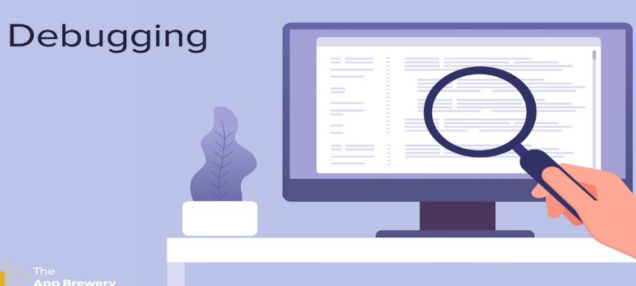

############DEBUGGING#####################

# # Describe Problem

# # Reproduce the Bug

# # Play Computer

# # Fix the Errors

# #Print is Your Friend

# #Use a Debugger

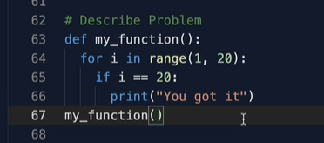

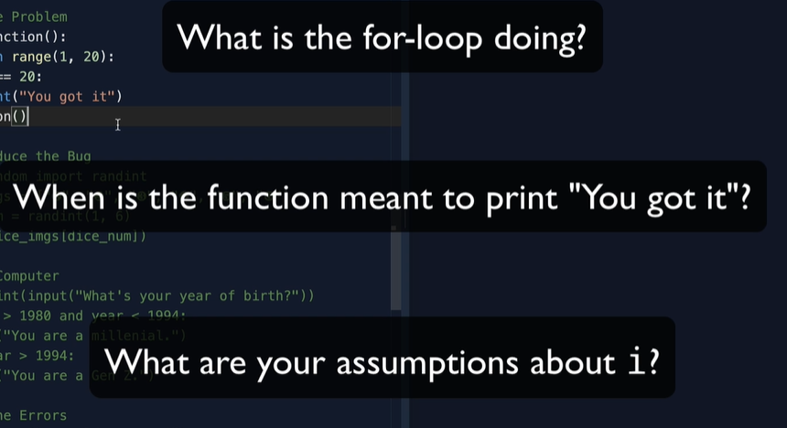









If the problem is unique ask if not search



